SportsInfo.com

*User Guide*

|  |  |  |  |
| --- | --- | --- | --- |
| **Supervisor.** | Ashir Irfan | |  |
| **Batch.** | PR2-202110G | |  |
| **Group.** | 1 | |  |
| **Serial No.** | **Enrollment Number** |  | **Student Name** |
| 1. | Student1340502 | Tasmeet | Javeed |
| 2. | Student1340500 | Arisha Shahzad |  |
| 3. | Student1333808 | Hamza khan |  |

eProject: SportsInfo.com

***USER GUIDE***



1.

**Welcome**

(

*0*

*.Index.html*

)

2.



*Figure 1: Home Page To SportsInfo.com*

**Home Page:**

1. Home page with suitable logo
2. Menu With Site Information
3. The site should provide the information about following sports:
4. Football
5. Cricket
6. Judo
7. Tennis
8. Motorcycling
9. Volley Ball
10. Golf
11. Chess
12. Billiards
13. Athletics

1. The information about a particular sport should include:

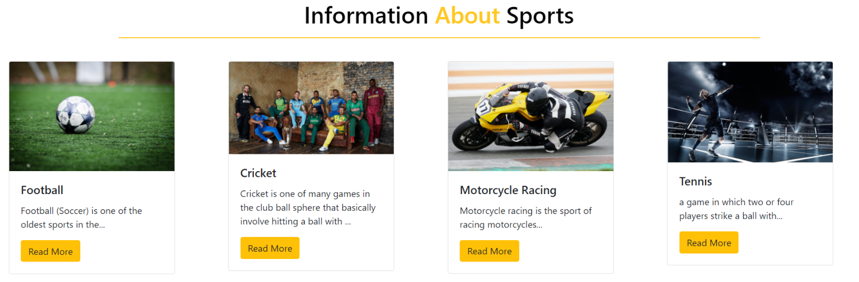 Information:



* How Many Players Play the Game.
* Strategy of the game.
* It is a team game.
* Rules of the game.
* Some important facts about the game (when was the game invented, any special tournament like World cup / Wimbledon is played etc).
* Statistics / Records.
* Also include the images of the players, clicking on which should display the detailed information about that player.
* Which all countries play this game.



2

**About Us Page:**



About Us Page has introduced our Company.

Sports Analysis Team:



This Section Describes Sports Analysists.

Contact Us Page:

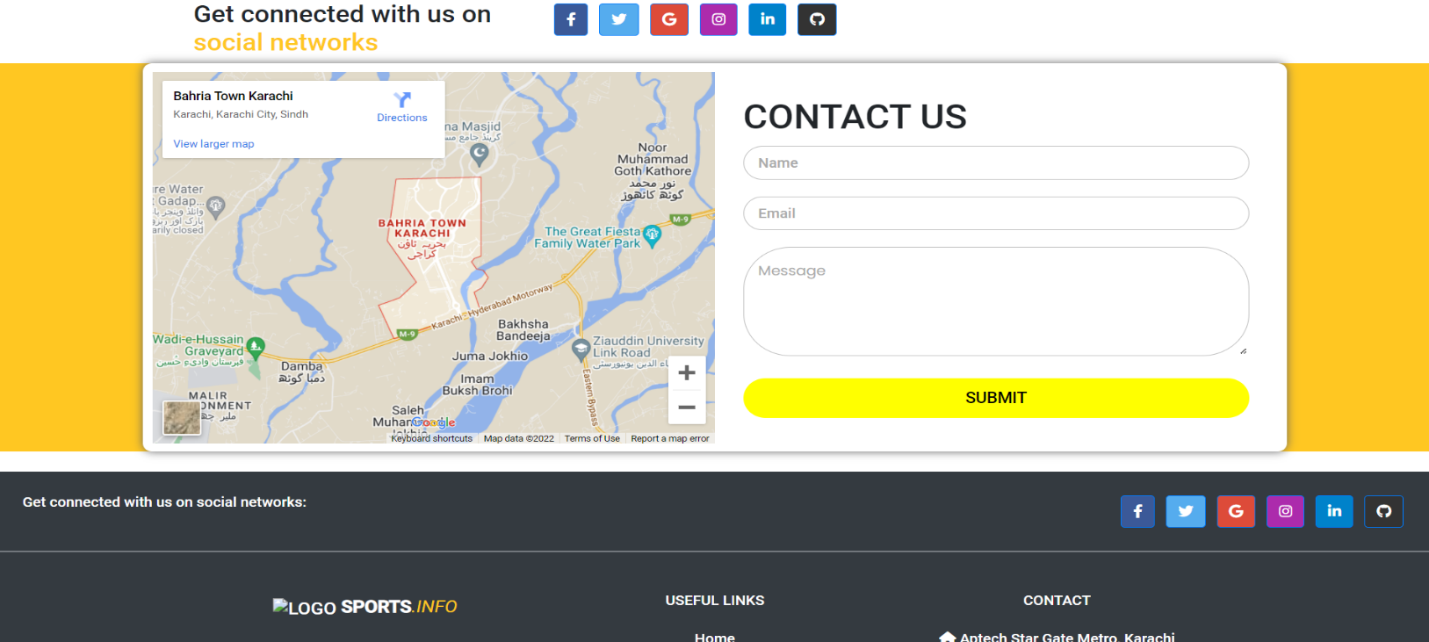

User Can Easily Contact with Us.